INTELLECT NMEA 0183 & N2K INSTRUMENTS FROM DIGITAL YACHT
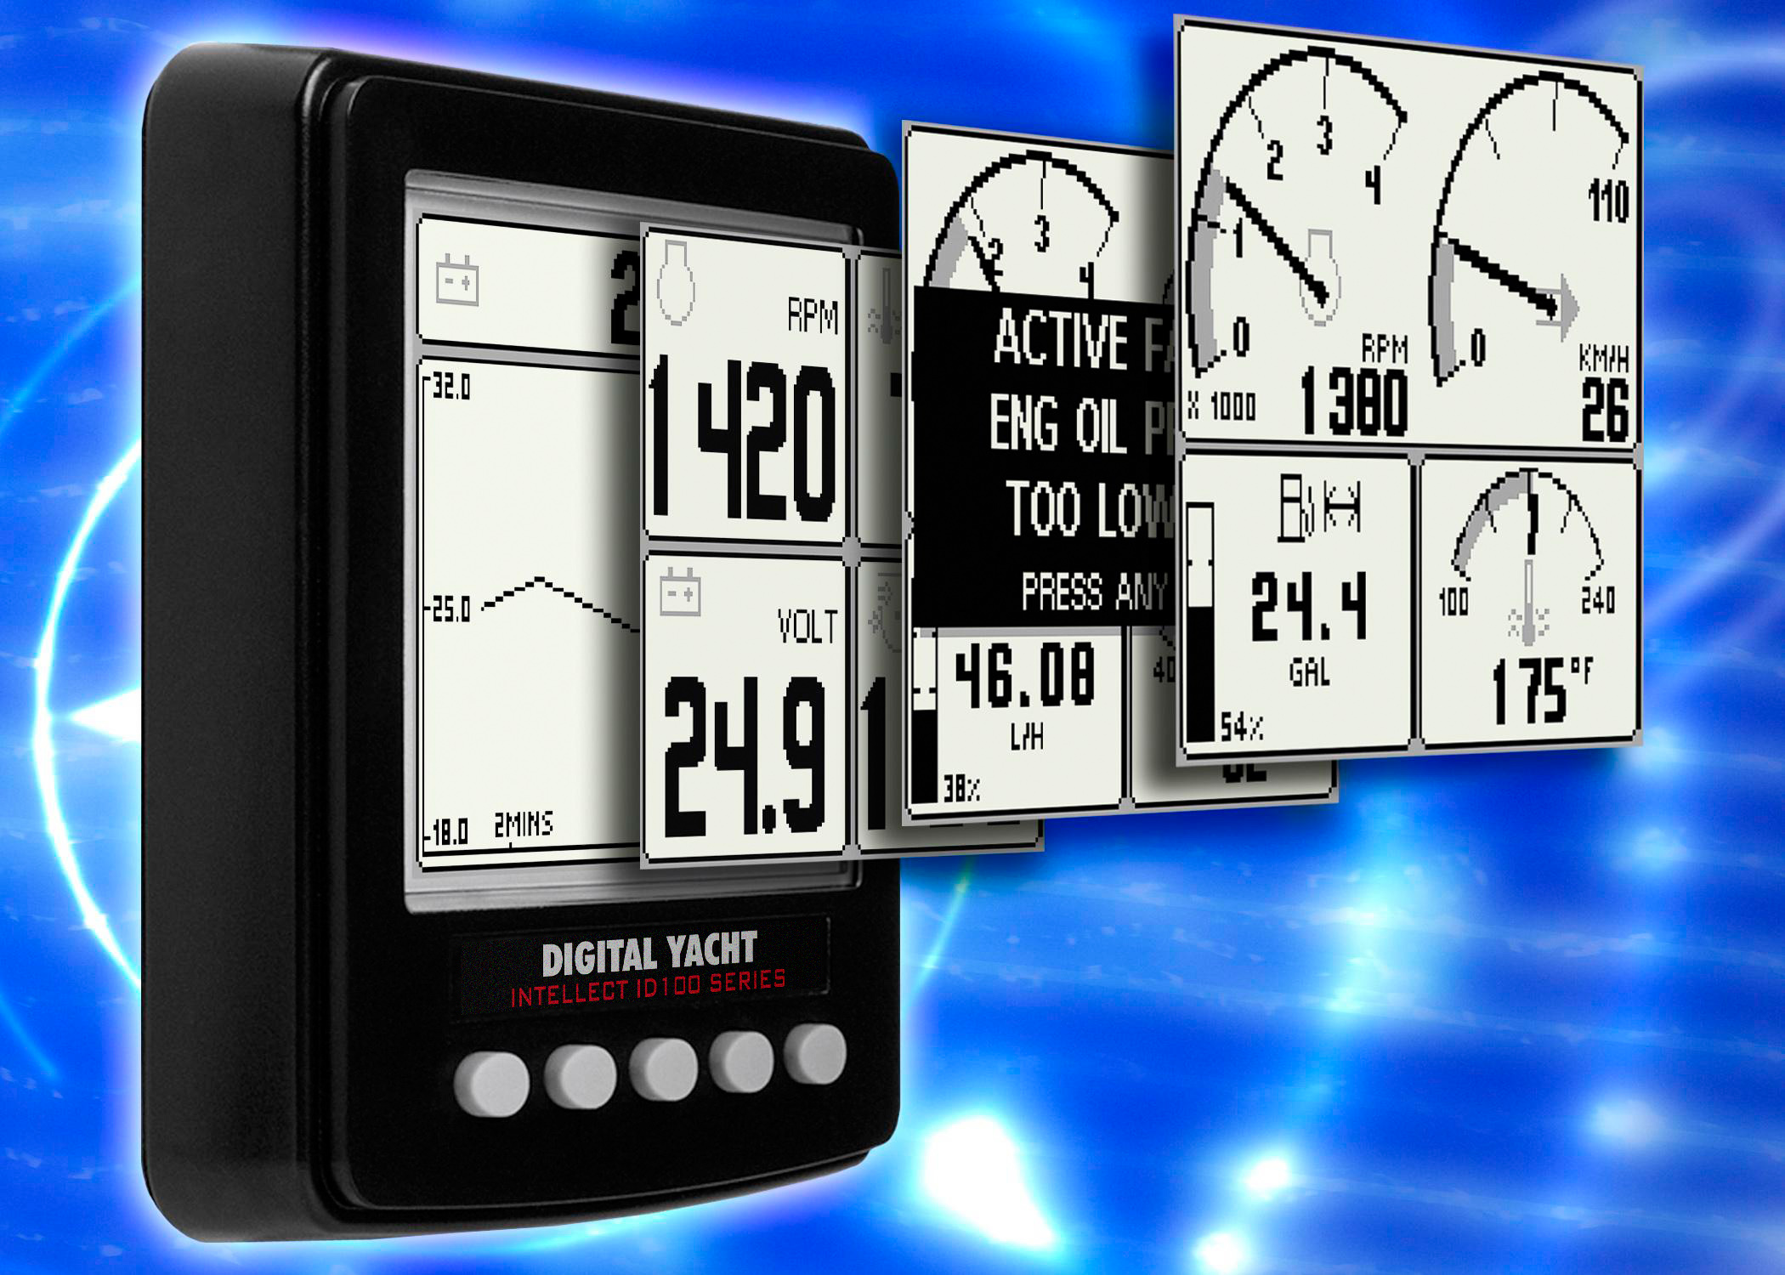
Digital Yacht have launched a new range of marine instrumentation capable of displaying almost any onboard navigation or engine information. The series is called Intellect and there are two types of instrument available.
The ID100 is dedicated to monitoring traditional depth, speed, heading, GPS and wind information plus also engine data available through a NMEA 2000 (N2K) data network and the ED100 is designed to monitor J1939 engine data such as fuel flow, pressure, temperature, alternator current/voltage, RPM and so on – a format normally utilised by diesel inboard manufacturers.
Both sunlight viewable, totally waterproof displays utilise the industry standard 110mm x 110mm format and feature a large, backlit LCD screen with a resolution of 160 x 128 pixels. Pages of data can be displayed in a variety of different formats including single line, jumbo displays, historical trend graphs or multi-line dual and quad screens. Data can also be displayed in graphical format mimicking a traditional analogue gauge. Users can quickly and easily instruct an Intellect instrument to display their chosen format and data information through 5 simple buttons (soft keys) on the front panel.
The ID100 instrument connects to any NMEA 0183 or N2K system. It also acts as a gateway between these two systems converting data from either format to allow older legacy NMEA 0183 systems to integrate with newer N2K products and vice versa. In its simplest form, an ID100 instrument could act as a navigation repeater for a plotter or GPS and also convert this data to the newer N2K standard but it’s equally capable of displaying a variety of data from a sophisticated N2K network.
The engine monitoring display, ED100 connects to systems through the J1939 Canbus standard adopted by many inboard diesel manufacturers including Volvo, Caterpillar and Man.

If you’re creating a system from scratch, a variety of active transducers based on the NMEA data standard are available including wind, compass, GPS, speed and depth. Systems can also be calibrated through the display and Intellect products can be networked together to form a larger system, sharing the same calibration values to simplify setup.
The ID100 and EM100 are priced competitively at £279.95 including VAT. For further details, contact Digital Yacht on 01179 554474 or visit www.digitalyacht.co.uk
- ENDS -
For further information, please contact:
Digital Yacht Ltd., Digital House, Unit 10 City Business Park, Easton Road, Bristol, BS5 OSP, UK.
Telephone: +44 (0)1179 554474
Email: sales@digitalyacht.co.uk
Web: www.digitalyacht.co.uk

For further press information, please contact:
Tina Mansell at The Mansell Agency
Telephone: +44 (0)1202 701705. Mobile: +44 (0)7973 850012
Email: tina@themansellagency.com
www.themansellagency.com

